**This Week at a Glance in Eighth Grade English Class**:

**\*\* Website:**  ***Check out our Teacher Websites for important notes and information***

**Feature Article Due April 30th**

**Bring FULLY CHARGED Chrome Books ALL WEEK**

[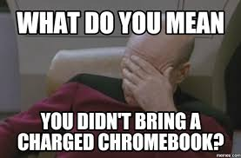](http://www.google.com/url?sa=i&rct=j&q=&esrc=s&source=images&cd=&cad=rja&uact=8&ved=0ahUKEwjqkp_OxbPTAhUGOBQKHSSnD1gQjRwIBw&url=http://memes.com/img/1443105&psig=AFQjCNG4RSa11sZBCokVJXbdQk3s4vwEYg&ust=1492795178967216)

**Monday, April 16, 2018 Quarter 4 Begins**

**In Class:** Hand out and Discuss Feature Article Assignment

Prescription Drugs Feature Article: Read, Highlight, Answer Questions

**Homework:** Choose a topic from the assignment sheet

[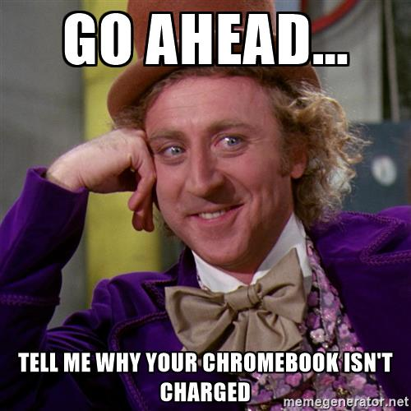](https://www.google.com/url?sa=i&rct=j&q=&esrc=s&source=images&cd=&cad=rja&uact=8&ved=0ahUKEwiygraByrPTAhWE7xQKHeo0D6AQjRwIBw&url=https://memegenerator.net/instance/62368521&psig=AFQjCNG4RSa11sZBCokVJXbdQk3s4vwEYg&ust=1492795178967216) Complete the Feature Article Organizer Step One

**Tuesday, April 17, 2018**

**In Class:** Researching the Topic (**3** Documents/Sources)

Complete the Feature Article Organizer Step Two

**Homework:** Finish Classwork

Bring **3** Documents/Sources tomorrow (Digital or Hard Copy)

**Wednesday, April 18, 2018**

**In Class:** Feature Article Organizer Step Three

**Homework:** Continue working onFeature Article Organizer Step Three

[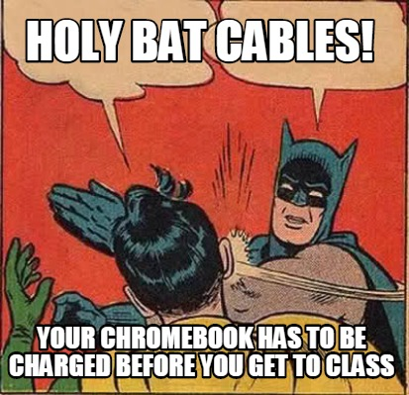](http://www.google.com/url?sa=i&rct=j&q=&esrc=s&source=images&cd=&cad=rja&uact=8&ved=0ahUKEwi25NK9yrPTAhXEXBQKHfpeBtwQjRwIBw&url=http://www.memecreator.org/meme/holy-bat-cables-your-chromebook-has-to-be-charged-before-you-get-to-class/&psig=AFQjCNG4RSa11sZBCokVJXbdQk3s4vwEYg&ust=1492795178967216)

**Thursday, April 19, 2018**

**In Class:** Continue working onFeature Article Organizer Step Three

**Homework:** Finish working onFeature Article Organizer Step Three

**Friday, April 20, 2018**

**In Class:** Feature Article Organizer Step Four

**Homework:** Continue working onFeature Article

**Next Week: Science Fiction…Feature Article…and more!**

**Remember that this is a plan. As in life, things may change!**



.